1、Firmware starts from 019 is the one without AES256, both 5W and 10W
2、Firmware starts from 119 is the one with AES256 16 groups, both 5W and 10W
3、Firmware starts from 219 is the one with AES256 255 groups, both 5W and 10W
please kindly note that radio with Firmware which starts from 219 should use special programming software, if you use wrong programming software , it wil make AES not work properly

26-3-12
To enable and disable TX/RX indicator from CPS

25-3-5
Solve the issue that after you set password and lock the radio, after power off and power on again, radio can enter the radio without password but without TX and RX

24-4-18: to add 255 groups for AES256, but to use this function, please use the latest programming software
CPS MD-UV380 Setup v2.41 for MD-UV380 and MD-UV390 common version 5W and 10W
CPS MD-UV390 Setup v2.41 for MD-UV380 and MD-UV390 GPS version 5W and 10W

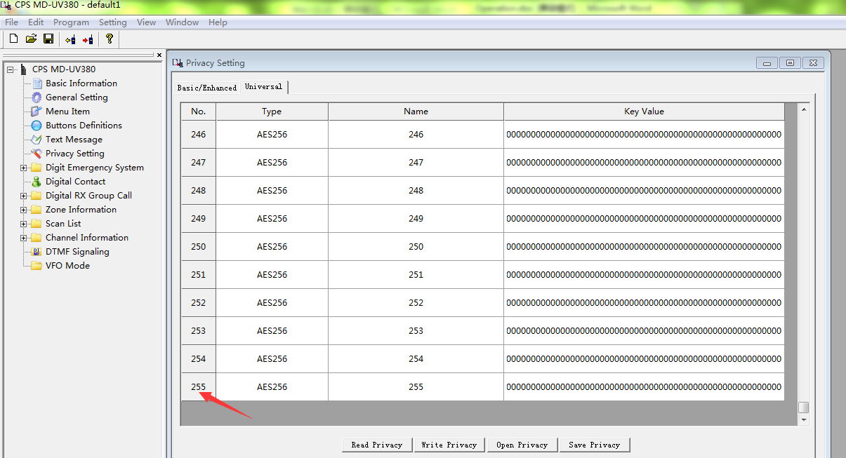

23-7-27: to solve the issue that keypad lock will be disabled after you turn off the radio and turn it on again

2021-5-7： to solve the issue that in DTMF dialing, when you press #, it will beep twice
Following two are for the version of GPS only
MD-UV390(CSV-GPS)-P19.06.bin (start from P) for GPS version for MD-UV380 and MD-UV390 with 100.000 contacts
MD-UV390(GPS-REC)-S19.06.bin(start from S) for GPS version for MD-UV380 and MD-UV390 with 10.000contacts and recording

Following two are for the version of non-GPS version only
MD-380(REC)-D19.06.bin(start from D) for common version for MD-UV380 and MD-UV390 No GPS version
MD-380(CSV)-V19.06.bin(start from V) for common version for MD-UV380 and MD-UV390 No GPS version

2021-6-5: to solve the issue that in the analog mode, if you set frequency without tone code, display will light up after the transmission when you release PTT,

2021-4-23： to be able to lock the keypad and side key, only PTT and volume knob and channel knob available
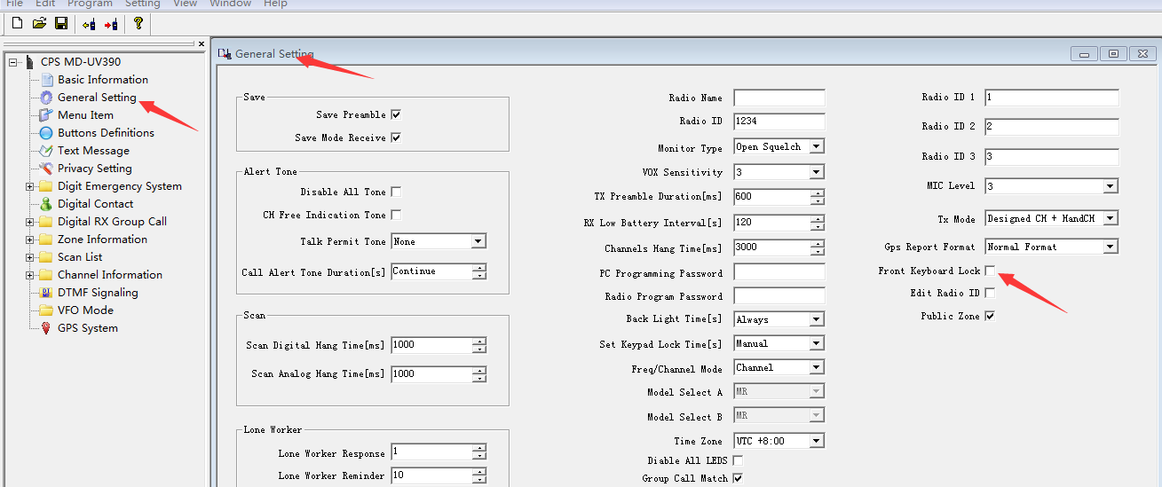

Following two are for the version of GPS only
MD-UV390(CSV-GPS)-P19.03.bin (start from P) for GPS version for MD-UV380 and MD-UV390 with 100.000 contacts
MD-UV390(GPS-REC)-S19.03.bin(start from S) for GPS version for MD-UV380 and MD-UV390 with 10.000contacts and recording

Following two are for the version of non-GPS version only
MD-380(REC)-D19.03.bin(start from D) for common version for MD-UV380 and MD-UV390 No GPS version
MD-380(CSV)-V19.03.bin(start from V) for common version for MD-UV380 and MD-UV390 No GPS version

Programming software version:
MD-UV390 V1.3 is for MD-UV380 and MD-390 GPS version
MD-380 V1.2 is for MD-UV380 and MD-390 no GPS version

- We change the assembling type of flexible cable to display for MD-UV380 and MD-UV390 and MD-380 and MD-390 and MD-9600 and MD-2017 to solve the blank display issue
- In the VFO mode, you can set offset now
- It has 120,000 contacts now, please kindly note that before you import CSV file into radio, please check your radio version first, it should be MD-UV380(CSV) and MD-UV390(CSV-GPS)
- You can enter into menu when the signaling coming in
- Address the issue that The radio will be frozen when the main band and sub band has the same frequency but in different slots
- Address the issue that in CSV version, the display will be in chaos when press # key
- adding the function of programming mutiple radio ID
- solve the issue of scan in VFO mode
- add the function of time setting to back to menu mode and standby mode
- the SQL level changed into level 0-9
- you can set mic gain
- address the issue of band A and band B cannot put in the different zone
- adding the functions of adding group call contact
- to solve the issue that error GPS location

Following two are for the version of GPS only
MD-UV390(CSV-GPS)-P18.16.bin (start from P) for GPS version for MD-UV380 and MD-UV390 with 100.000 contacts
MD-UV390(GPS-REC)-S18.11.bin(start from S) for GPS version for MD-UV380 and MD-UV390 with 10.000contacts and recording

Programming software version:
MD-UV390 V1.12 is for MD-UV380 and MD-390 GPS version
MD-380 V1.12 is for MD-UV380 and MD-390 no GPS version

Press side key 1 and PTT key to turn on the radio, the indicator blinks and open upgraded software
